Creation of a New Home Security System Using IoT Devices

*Nathan Cottrell*

*University of Portsmouth*

*Portsmouth*

[*up2109768@myport.ac.uk*](mailto:up2109768@myport.ac.uk)

**Abstract** — This project presents the design and implementation of a moderately low-cost portable smart home door and window security system using IoT devices. This report outlines the devices used and why each was chosen compared with alternative devices for each situation, an outline of the rough costs for each component needed to create the device, pseudo code, diagrams to show logic and data flow within the device and a final implementation made with available devices including a reflection on how the project went.

**Index Terms** — Internet of Things (IoT), home security, HC-SR04 ultrasonic sensor, Camera, smart devices, motion detection, real-time notification, intrusion detection, image capture, buzzer alarm system, pseudocode, logic diagram, smart home, design, implementation.

—————————— ◆ ——————————

# 1 Introduction

## Scenario

C

onsider a scenario where someone attempts to break into a home. Without an effective home security system in place, it may go undetected. This is a reality many people face. With a house being broken into approximately every 173 seconds in 2023/24 (Office for National Statistics, 2022)home security is becoming an increasing concern for UK citizens. Due to this IoT based smart home devices are gradually becoming more popular among the public with approximately "one in five Brits now own[ing] a video doorbell" (Buccieri, 2025) this rise in popularity is primarily due to the increased capabilities and affordability of these devices.

Many traditional home security systems can either be expensive or complex to install and many low-cost alternatives lack the capabilities to be truly effective. This demonstrates the need for a simple, effective home security system which was not be overly expensive and can be easily installed where the user needs.

## Solution

This was where a simple portable system which could be installed at any door or window in a property could come in useful.

The first part of the system included a sensor to detect when a door or window opens and a camera to snap a picture of the intruder before sending a notification to the user’s phone this is there to allow for the authorities to have some help in stopping criminals as they say that with Audible only alarms, defined as "alarms [that] set off a siren or bell", "due to the number of false alarms, police will only respond if there is confirmation of suspicious activity" (Thames Valley Police, n.d.). This device allows the user to immediately get that confirmation so they can take quick and decisive action to secure their property.

The second part of the device had the device wait for approximately 30 seconds to allow time for the person who triggered the device to enter a PIN otherwise an alarm would go off. This part of the device was meant to act as a deterrent against the intruder to stop them from entering and as a warning to neighbors about what is going on.

Overall, this device should allow for effective monitoring of the alarm system in order to make sure that it is a real threat and not a false alarm allowing for quicker responses to the burglary. It also provides an effective deterrent in the way of an alarm to attract attention and make the burglar feel exposed.

# 2 Details of the design

## Hardware components

T

he system could be split into three sections:

Firstly, there was the trigger mechanism which was made up of a HC-SR04 ultrasonic sensor rigged up directed at the door in order to detect a change in the distance from it to the door and send a signal to the next section of the device.

This was better as opposed to the other options, such as a button positioned such that when the door was fully closed it would be pressed and when opened it would stop pressing the button. This was because while being effective it would be difficult to implement reliably.

Furthermore, a tilt sensor attached to the door so when it moves the sensor would trigger, due to the change in the angle, this would be able to be implemented easily

enough. However, an issue with this approach was that while optimal it was currently not in possession of the developer.

|  |  |
| --- | --- |
| **Tilt Sensor**  *(Gravity: Digital 360° Tilt Sensor, 2025)* | **Ultrasonic sensor**  *( Ultrasonic Distance Sensor (HC-SR04), 2025)* |
| Working Voltage: 3.3~5V. | Power Supply:  5V |
| Range:  Only what it is  attached to | Range:  2cm – 400cm/4m |
| Connector:  Gravity. | Working  Frequency: 40Hz |
| Tilt Switch Angle: 45°±10° | Measuring Angle: 15 degree |
| Module Size:  22*30mm / 0.87*1.18 inches. | Dimensions: 43mm x 20mm x 15mm |
| Price:  £2.40 | Price:  £2.00 |

Table : Tilt and ultrasonic sensor comparisons

Secondly, there was the camera and email notification using the OV2640 which waited for a few seconds to allow for the door to be fully opened before taking a picture and sending it to the user's phone as a notification.

The OV2640 would be the better choice over the other option which would have involved using an OV7670 camera module due to the OV7670 not supporting compressed images and offering lower resolution as opposed to the OV2640 (Jackson, 2021).

|  |  |
| --- | --- |
| **OV2640** | **OV7670** |
| Array size:  1600 x 1200 | Array size:  640 x 480 |
| Output format:  YUV/RGB/Raw RGB Data/MJPEG | Output format:  YUV/RGB/GRB/Raw RGB Data |
| Pixel size:  2.2 x 2.2 μm | Pixel size:  3.6 x 3.6 μm |
| Image transfer rate:  1600×1200@15fps, SVGA@30fps, CIF@60fps | Image transfer rate:  VGA@30fps |
| Power consumption  125mW | Power consumption  60mW |
| Power consumption:  Core: 1.3V DC ± 5% Analog: 2.5~3.0V DC I/O: 1.7V to 3.3V | Power consumption:  Core: 1.8V DC ± 10% Analog: 2.45~3.0V DC I/O: 1.7V to 3.0V |
| Price:  More expensive | Price:  Cheaper |

Table : OV2640 vs OV7670 comparison (Jackson, 2021)

To send a notification to the user, the chosen option was to utilise SMTP to send an email to the user's phone. This approach would not require any specialist hardware and could be done entirely through code (Email: Examples — Python 3.7.3 Documentation, 2019).

On the other hand, another method of sending notifications to the user includes using an ESP8266 to create a web server and connecting through Wi-Fi to display data and send notifications through Pushover which was a notification service that integrates with many applications (Santos, 2023). This choice was not chosen due to the time restraints around this project.

The next section was the alarm where it then waited for a bit longer to allow the person a chance to input a pin on a membrane switch module to shut off the alarm which used a buzzer and would trigger if the pin was not put in in time. However, the buzzer would still go off if the pin was input after the timer was over.

The membrane switch was chosen over alternatives such as a 3x4 matrix array keypad or an Interfacing AS608 Optical Fingerprint Sensor Module due to the membrane switch and keypad being very similar devices and the membrane switch being easier for users as the user does not need to go through the trouble of setting up a finger print scan for everyone who was allowed in as opposed to telling them the PIN for the membrane switch.

Also, the buzzer was chosen over alternatives such as a speaker as it was unnecessary to use a speaker as opposed to a buzzer due to not requiring the extra functions provided by the speaker.

The last feature is an on/off button intended to allow for easy transportation of the device. A button was chosen over alternatives such as a switch as it was accessible during the project. However, a switch would generally make for a better module to be used for turning the device on/off due to it already having set states as opposed to tracking button presses.

### Wiring

#### Passive Buzzer Wiring

Buzzer GND --> Arduino GND

Buzzer --> 100Ω resistor --> Arduino pin 13

#### HC-SR04 Ultrasonic sensor Wiring

HC-SR04 VCC --> Arduino 5v

HC-SR04 ECHO --> Arduino pin 11

HC-SR04 TRIG --> Arduino pin 12

HC-SR04 GND --> Arduino GND

#### Membrane Switch Wiring

Matrix Row 1 --> Arduino pin 3

Matrix Row 2 --> Arduino pin 4

Matrix Row 3 --> Arduino pin 5

Matrix Row 4 --> Arduino pin 6

Matrix Column 1 --> Arduino pin 7

Matrix Column 2 --> Arduino pin 8

Matrix Column 3 --> Arduino pin 9

Matrix Column 4 --> Arduino pin 10

#### Button

Button GND --> Arduino GND

Button --> Arduino pin 2

## Software design

### Pseudo-code

#### Ultrasonic sensor

*Define ultrasonic sensor*

*Define duration*

*Define distance*

Setup()

get initial reading

loop()

get current reading

if current reading - initial reading >= 10

execute rest of code…

get reading

*Set ultrasonic sensor to low*

*Delay for two microseconds*

*Set ultrasonic sensor to high*

*delay for ten microseconds*

*Set ultrasonic sensor to low*

*Calculate the distance*

*Divide the speed of the sound wave by 2 (there and back)*

#### Keypad

*Define keypad*

*rows = 4*

*cols = 4*

*device = off*

*hexakeys[rows][cols] = {*

*Buttons on keypad In matrix*

*}*

*colpins[rows] = pins*

*rowpins[cols] = pins*

start timer

*If (key pressed = #)*

*If pad = password*

*Access granted*

*If timer = 30 seconds*

*Buzzer on*

*Void read keypad()*

*get key pressed*

*If key pressed != #*

*pad += new key pressed*

#### Buzzer

Define buzzer

loop()

set buzzer

if timer = 30 seconds

buzzer on

*void setup() {*

#### On/Off button

*void loop() {*

if button is pressed

Enter pin

Device = on/off

Check if the device is on

*Set input/output of the ultrasonic sensor*

*}*

If device = on

Execute the rest of the code…

#### Picture

*Import serial*

*Import cv2*

*Import time*

*Import os*

*Set serial port*

*Set directory for saved images*

*Make the directory if it does not exist*

*Open camera*

*If the camera does not work, then exit*

*while true*

*if port has information waiting*

*read data*

*if command = take picture*

*take picture*

*if picture is taken*

*timestamp = year-month-day*

*file name = image-timestamp.jpg*

#### Email

*Import email*

*Smtp port*

*Smtp server*

*Email from*

*Email to*

*password*

*send email()*

*message from*

*message subject*

*message to*

*add body of the email*

*add Image to the email*

*Encode attachments*

*Connect to SMTP*

*Send email*

*Disconnect*

### Logic diagram

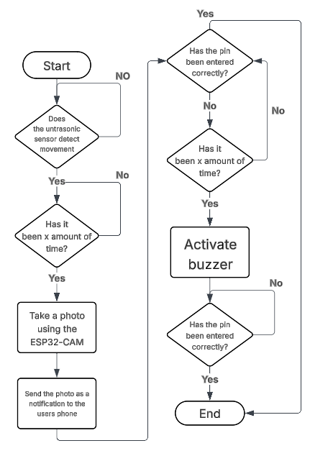

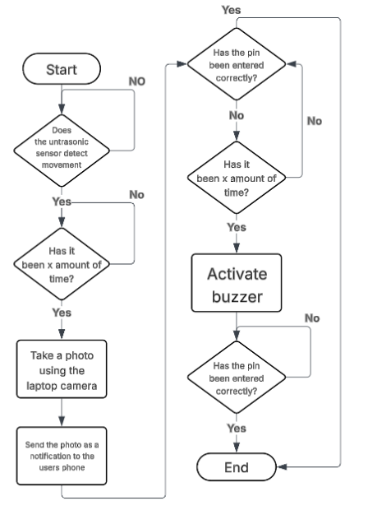

Figure : Logic diagram

## Working conditions

In order for the device to work it has to be pointed directly at the surface you want it to monitor with no obstructions. This allows for the

# 3 Implementation

## Limitations

Due to hardware limitations for this implementation, the device instead used an HC-SR04 ultrasonic sensor as an alternative to the tilt sensor, an Arduino board with a laptop webcam instead of an OV2640. This slightly changed how the project was implemented however these changes did not have significant effects on the functionality of the device.

## Ultrasonic sensor

To implement the ultrasonic sensor, the developer used Arduino code to send out a sound wave at the object it was pointing at thousands of times a second to maintain high accuracy and ensure responsive activation. This sound wave then returns to the ultrasonic sensor and the distance was then calculated using duration * 0.034 / 2. The code then outputs this distance for testing and clarity purposes.

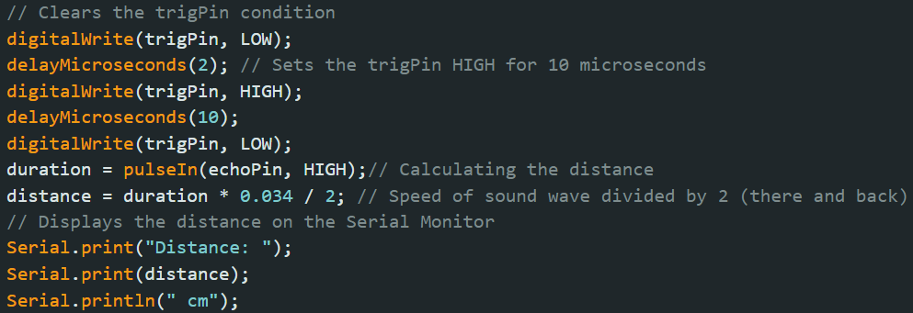

Figure : ultrasonic sensor distance measuring

## Buzzer

To implement the buzzer, the developer had a timer which would start counting once the ultrasonic sensor detects movement. Once this timer reaches 30 seconds it would go through the if statement as shown in figure 3. This if statement activates the buzzer for three seconds, which would be adjusted to be longer outside of an example scenario and then resets the variables and takes a new baseline reading in case the door was left open when it resets to avoid a loop.

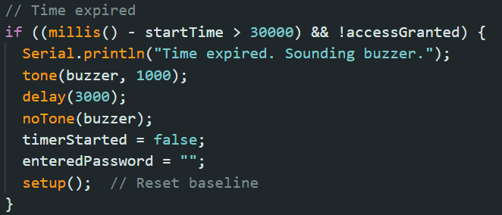

Figure : Code for the alarm

## Camera

To use a laptop camera to take pictures, the developer had to make the Arduino code send out a message on the connected port to make a piece of python code use the laptop camera to take a picture and save it. Furthermore, each image was saved in a folder called Captured_Images and named using a timestamp to avoid multiple files with the same name.

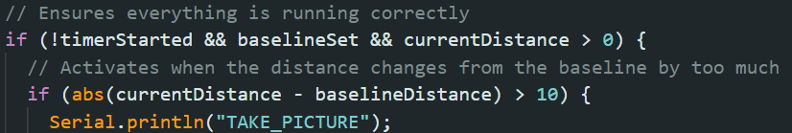

Figure : Code to activate the python code

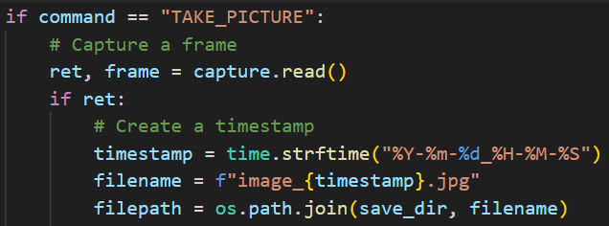

Figure : Code to take a picture

## Email

To implement the device having the ability to send emails, the developer had to import SMTP modules into python and get an application password for a new Gmail account. This allowed the code to connect to SMTP and attach images and text to an email to alert the user, at the email they input, that there has been a security issue as seen in figures 6&7.

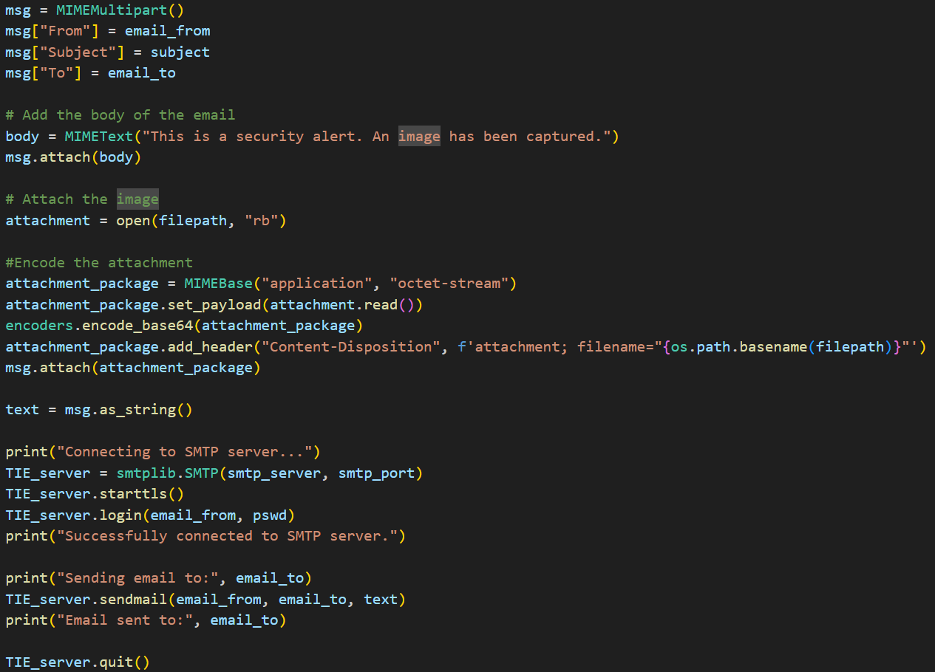

Figure : Email code

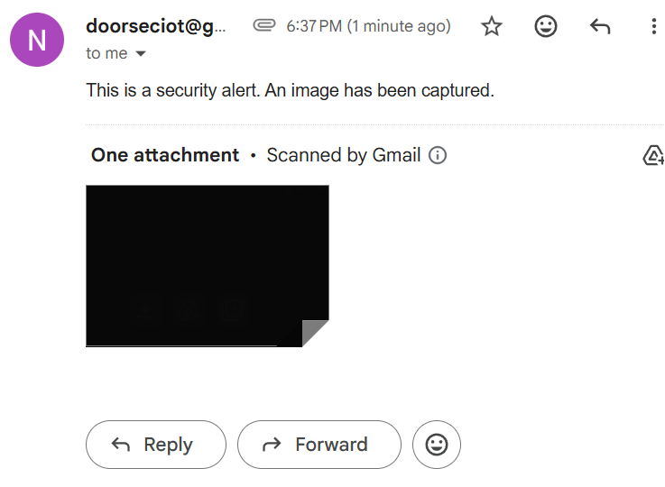

Figure : Email sent with attachment by code

## Keypad

To implement the keypad, the developer created a matrix which included each of the values on the keypad and then linked each row and column of the keypad to the pin it was attached to on the Arduino.

Afterwards the developer added code to check which buttons are being pressed and if, when entered, the password was correct.

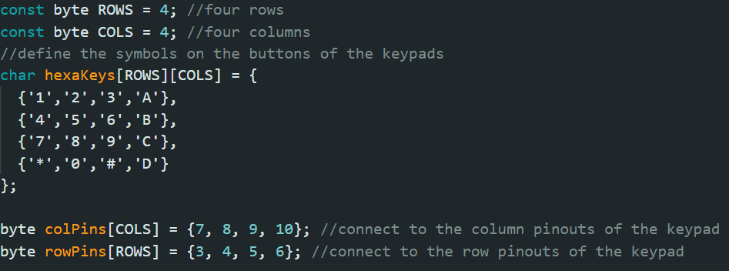

Figure 8: Code setting up the keypad

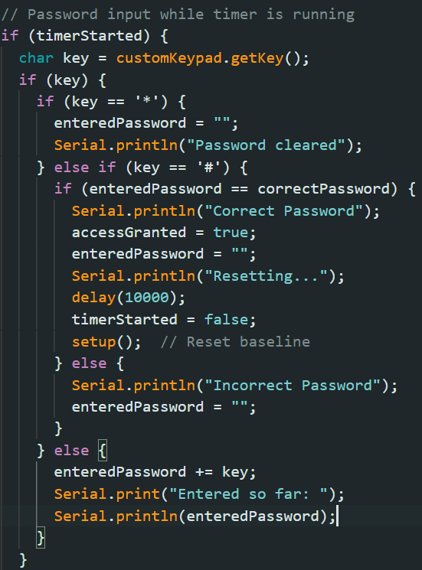

Figure 9: Code to check the password and handle inputs

## On/Off Button

To implement an on/off button the developer had to add code to check the state of the button to see if it should be on or off and then it asked the user to input the password on the keypad in order to change the device from on to off and vice versa otherwise the alarm goes off. This was done to ensure that it cannot be turned off by anyone who the user hasn't told the pin and add an extra layer of security to the device.

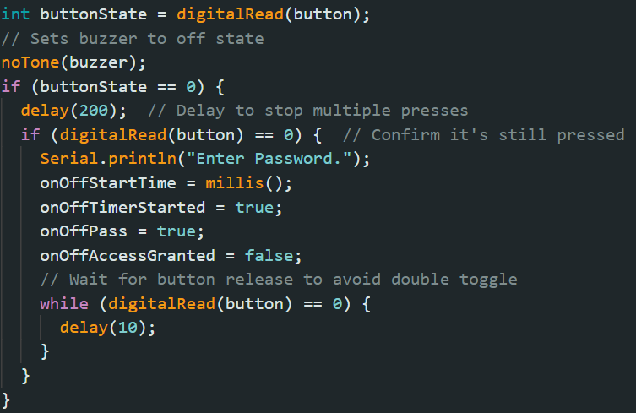

Figure 10: Code to check if the device is On/Off

## Wiring

To wire everything together the developer used a mixture of M-M and M-F wires with a breadboard to allow for additional connections and to attach the buzzer and resistor.

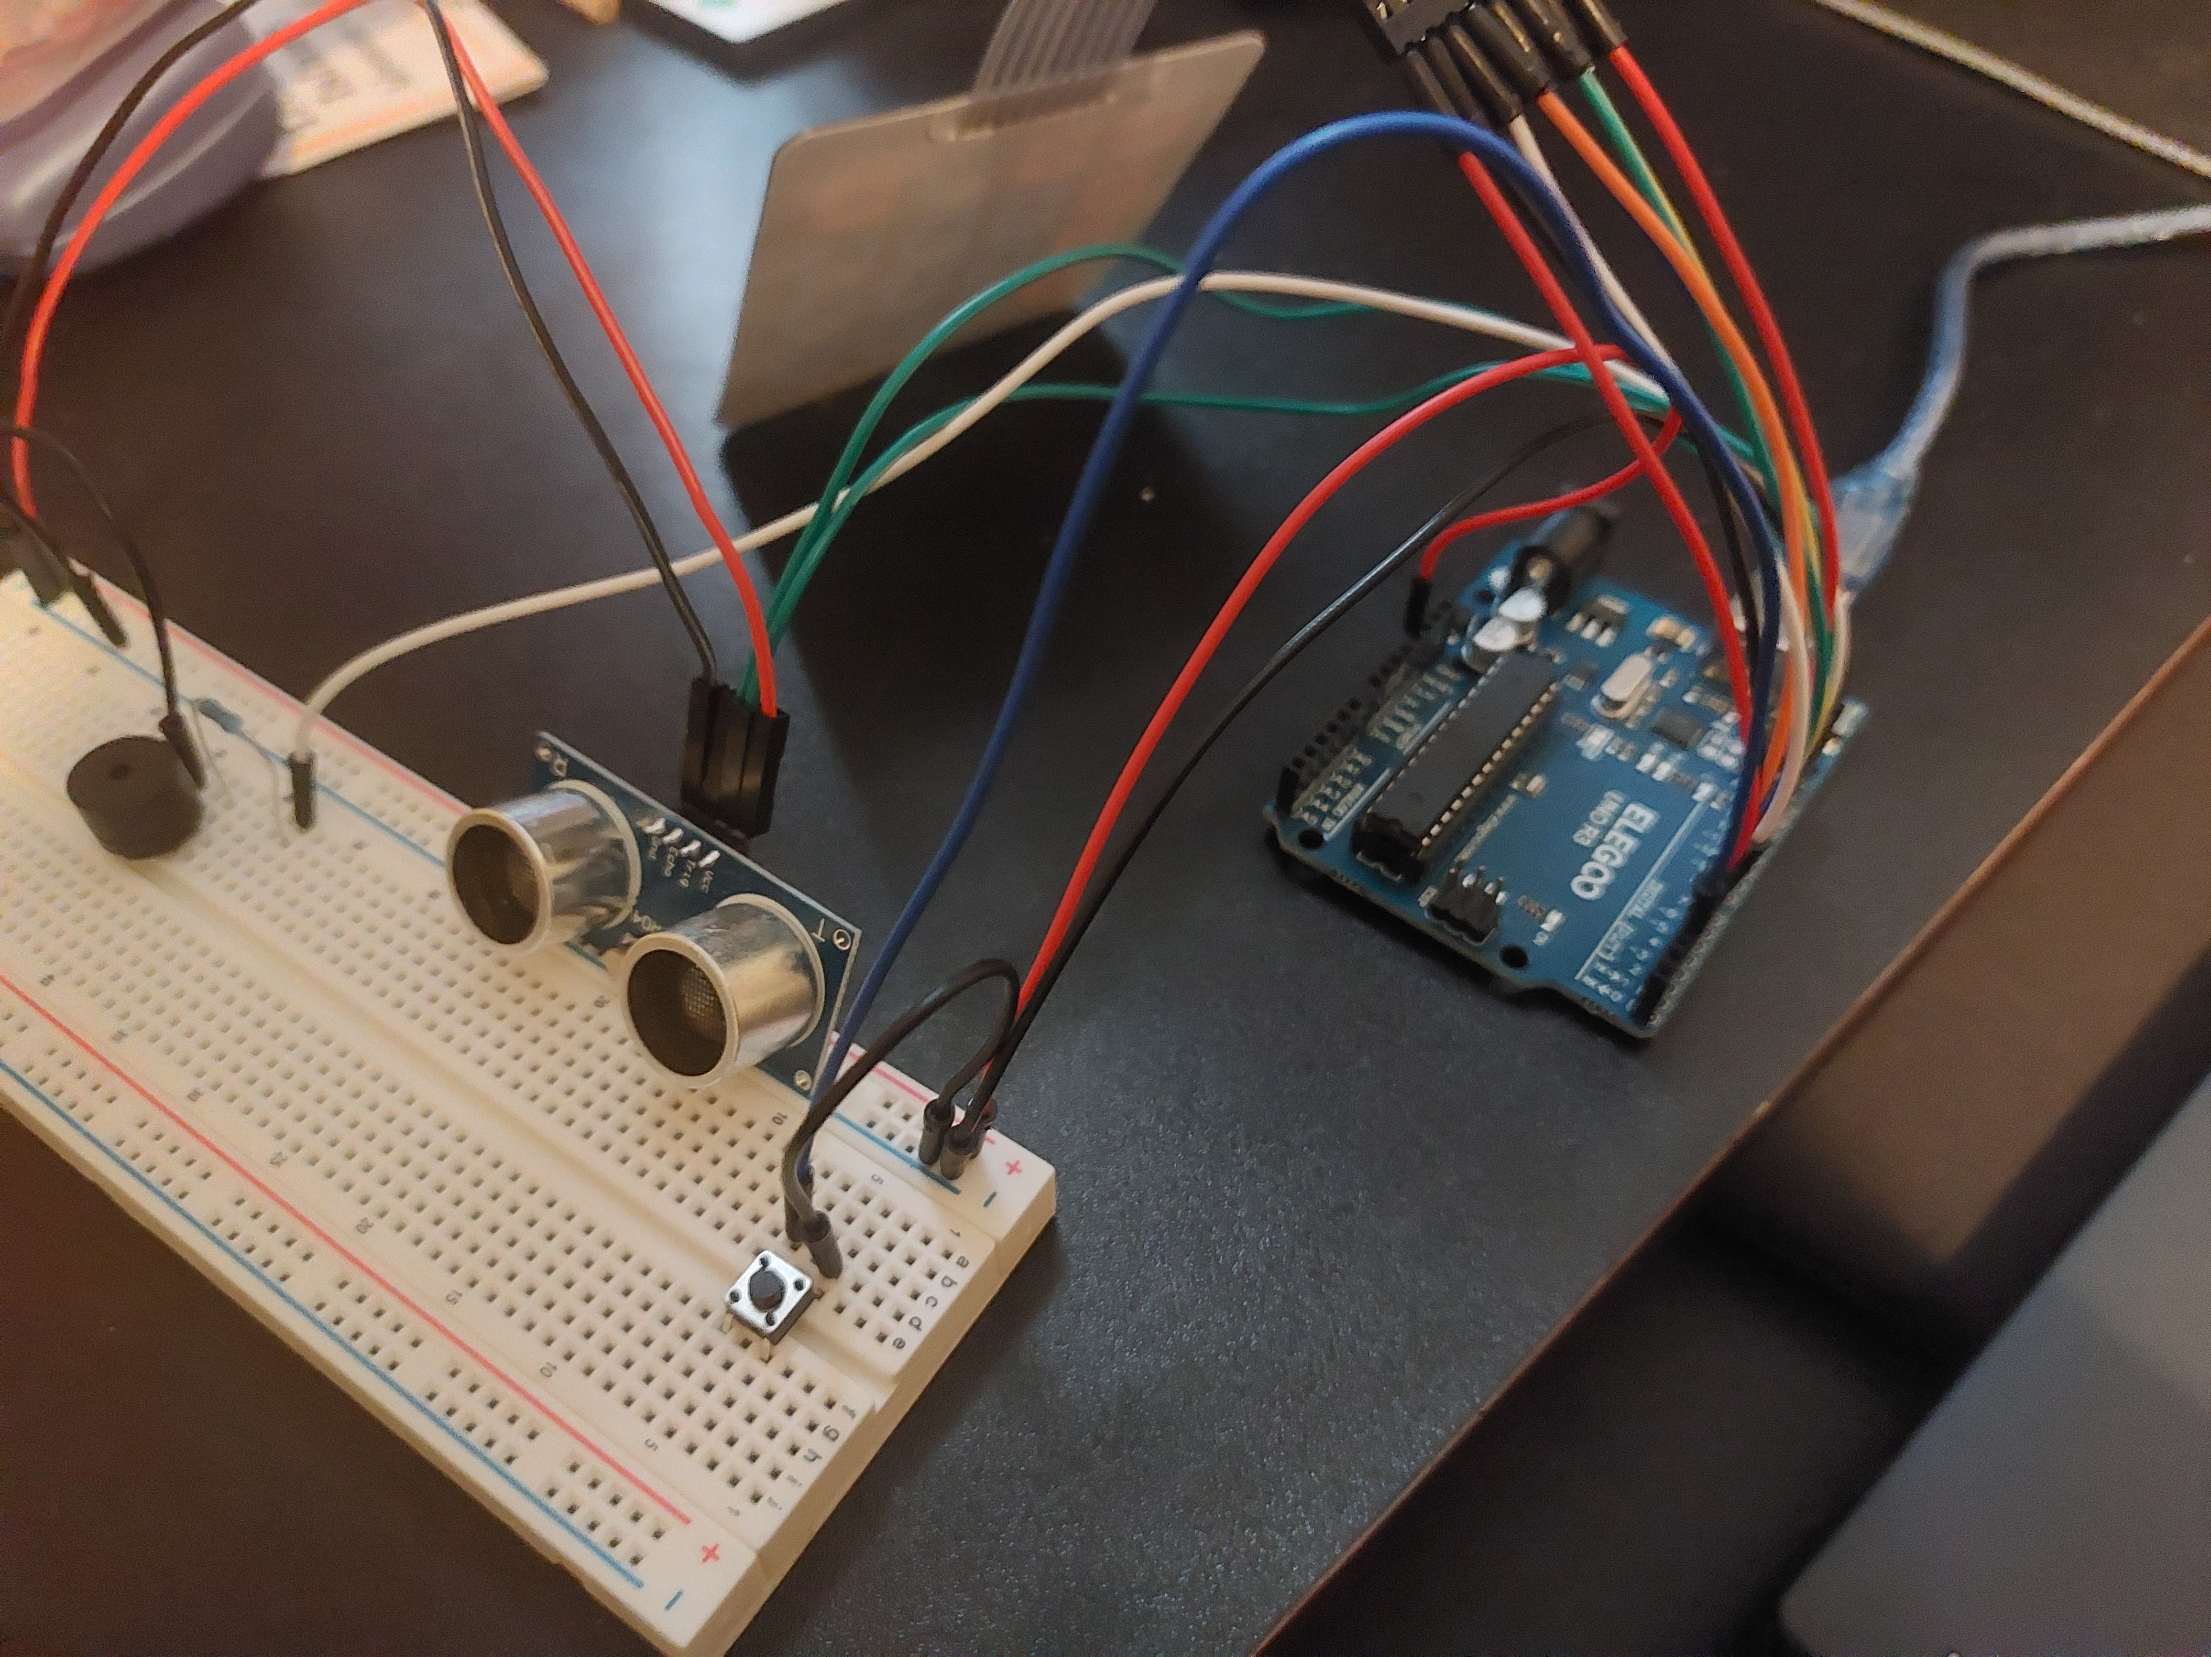

Figure 11: front image of the device wired up

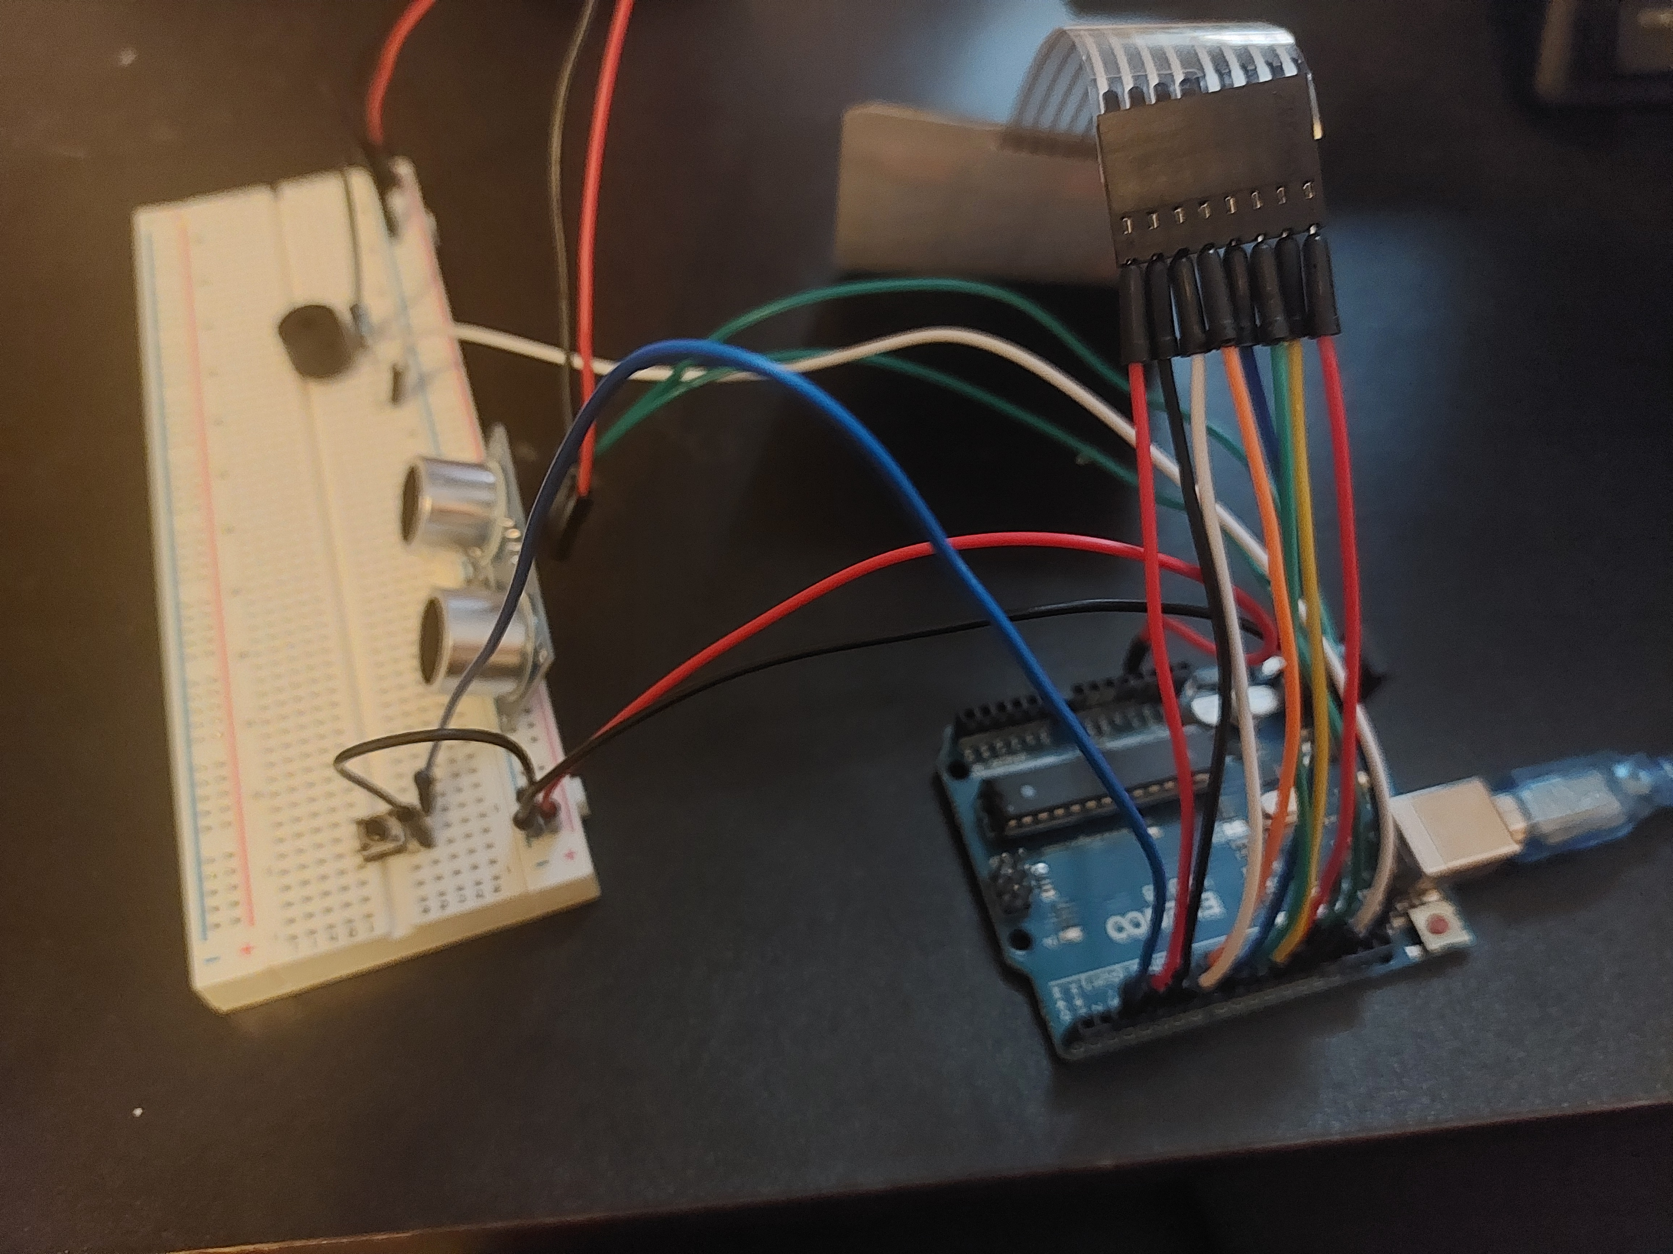

Figure 12: side image of the device wired up

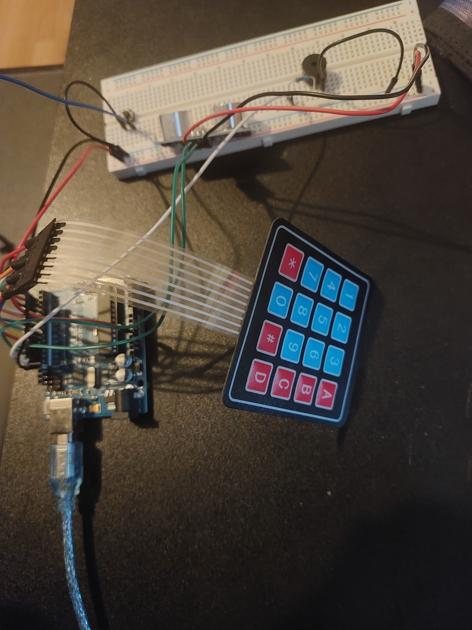

Figure 13: back image of the device wired up

# 4 Discussion and conclusion

## Summary of design

The project aimed to create a compact, entrance-monitoring device for home security. It used an HC-SR04 ultrasonic sensor to detect movement by measuring the distance between itself and the targeted entry point. This device was chosen for its ability to measure up to 4 meters and its availability for the project.

When the sensor detects a change in distance, indicating the entrance has opened, it captures an image using a laptop camera (used in place of a dedicated camera module) and sends it to the user via SMTP. After this, a 30-second countdown begins. During this time, the person who entered must input a PIN on a membrane keypad. If no valid input is received, a buzzer, selected as it is a readily available alarm substitute, is activated.

Furthermore, the device also includes a button to turn the device on and off to allow for the device to be transported without it triggering. When pressed this button would ask the user to input the PIN to ensure security and mitigate the risk of the device being turned off by a burglar.

## Evaluation of the device

The device accomplished the majority of its goals and, in its current form, is able to successfully monitor an entrance, activating reliably when movement is detected.

However, the device lacks portability due to its components being exposed without a container. Additionally, there is a lack of user-friendliness, as it offers no application front-end for user interaction, although once active it requires very little.

The most significant issue with this iteration is with the ultrasonic sensor, which triggers off any movement in front of it, regardless of whether it was intended entrance or not. This flaw could be mitigated through using a different sensor type such as a tilt sensor which would be much more targeted.

Furthermore, research involving 50 experienced burglars found that 30 claimed that alarms would not deter them, potentially due to alarms signaling that the house may contain valuable targets (Tilley et al., 2015). This can create an argument that alarms are not as effective as a deterrent as some other studies claim.

## Alternative solutions and recommendations

Throughout this report several different alternative components and design approaches were discussed to possibly enhance performance, usability, or scalability. One possible enhancement includes using a tilt sensor to detect when the entrance was moving as this would have much lower risks of false triggers when compared to the HC-SR04 Ultrasonic sensor.

Additionally, the current system sends emails through SMTP for alerts. Future versions could benefit from faster more user-friendly methods such as push notifications through a dedicated mobile app.

It is recommended that future iterations explore these options in order to improve user experience and detection accuracy, while still keeping the device affordable and easily implementable for users.

## Future improvements

Future hardware improvements could include miniaturising the device and integrating a proper casing to house all components securely. This would enhance durability and make placement at entry points easier and more practical for users.

Furthermore, future improvements could give the device its own power supply to ensure it does not need to be plugged in constantly further enhancing the portability aspect.

Future potential software upgrades include incorporating basic AI or machine learning techniques to differentiate between false triggers and actual security threats, improving the system's reliability.

Additionally, implementing remote configuration would make the device far more user-friendly as it could allow the user to change their PIN, make it easier for the recipient to set their email address, and receive push notifications through the use of a web or mobile application.

# 5 References

Office for National Statistics. (2022). UK Burglary Statistics (2022) - a Home Burgled Every 173s! Www.cladcodecking.co.uk. <https://www.cladcodecking.co.uk/blog/post/uk-burglary-statistics>

Buccieri, S.-M. (2025, January 23). Doorbell cameras: Do they provide peace of mind or paranoia? BBC News. https://www.bbc.co.uk/news/articles/clyzrrrrz3qo

Jackson, L. (2021). *OV2640 vs OV7670: Spec Comparison, Sample Images, Datasheets, Lens Options, Pinouts, Compatibility, and Tutorials*. [online] Arducam. Available at: https://www.arducam.com/ov2640-vs-ov7670-detailed-comparisons-and-resources/.

*email: Examples — Python 3.7.3 documentation*. (2019). Python.org. https://docs.python.org/3/library/email.examples.html

*Gravity: Digital 360° Tilt Sensor*. (2025). The Pi Hut. https://thepihut.com/products/gravity-digital-360-tilt-sensor-for-arduino

*Ultrasonic Distance Sensor (HC-SR04). (2025).* The Pi Hut. https://thepihut.com/products/ultrasonic-distance-sensor-hcsr04

Santos, S. (2023, May 18). *ESP8266 NodeMCU: Send Pushover Notifications (Arduino IDE) | Random Nerd Tutorials*. Random Nerd Tutorials. https://randomnerdtutorials.com/esp8266-nodemcu-pushover-arduino/

(n.d.). *SECURE YOUR HOME KEEP BURGLARS OUT*[Review of *SECURE YOUR HOME KEEP BURGLARS OUT*]. Https://Www.thamesvalley.police.uk; Thames Valley Police. Retrieved May 6, 2025, from https://www.thamesvalley.police.uk/SysSiteAssets/media/downloads/thames-valley/advice/home-security-guide2.pdf

Tilley, N., Thompson, R., Farrell, G., Grove, L., & Tseloni, A. (2015). Do burglar alarms increase burglary risk? A counter-intuitive finding and possible explanations. *Crime Prevention and Community Safety*, *17*(1), 1–19. https://doi.org/10.1057/cpcs.2014.17